Narrative: Enhancement Three: Databases
SNHU CS 499
Kevin Bristow

- Briefly describe the artifact. What is it? When was it created?
The artifact is the full-stack website that I am creating. It’s a digital library/note taking app where users have personal accounts and can add notes for individual books in their library. This tech-stack consists of MongoDB, Express, and NodeJS. My end goal is to have this website hosted for others to use.
- Justify the inclusion of the artifact in your ePortfolio. Why did you select this item? What specific components of the artifact showcase your skills and abilities in software development? How was the artifact improved?
I decided to create a full-stack website because it meets all the course outcomes and because it shows that I can create a working product. This artifact requires that I set up and connect a database to the website to provide dynamic data, which is common practice is production applications.
Below are screenshots of the database:
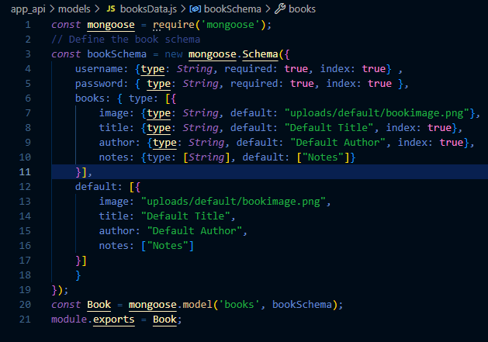
This is the MongoDB schema that I designed. I decided to design it in this manner because it made the most sense to me.
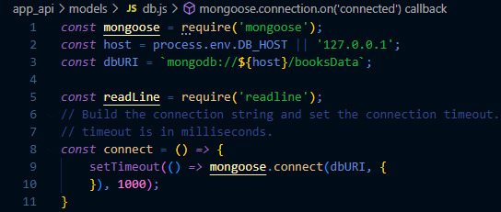
This image shows the code that connects the database to my server.
Accomplishing both of these tasks has been an informative process and the skills I have developed from it are translatable into the corporate world.
- Did you meet the course outcomes you planned to meet with this enhancement in Module One? Do you have any updates to your outcome-coverage plans?
I believe I have met the course outcomes that were planned. All the outcome-coverage plans are almost complete; since I am using one artifact for this whole capstone, the outcomes will be achieved when the project is complete.
- Reflect on the process of enhancing and modifying the artifact. What did you learn as you were creating it and improving it? What challenges did you face?
This has been a fun and informative process, especially when the application uses the database to render dynamic data and validate user login credentials. I learned that a lot more goes into developing databases and having them interact with the server, especially in terms of security. The hardest part about the process was learning about the database software and how to write the code to design it and connect it to the server.

